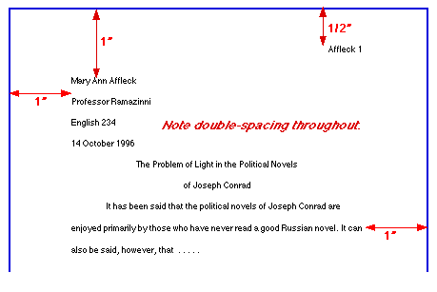
Formatting an MLA Paper with MS Word 2010

- In the Home tab, select Times New Roman for the font and select 12 for the size. Also, click the arrow button at the bottom right of the Paragraph section. Under Line Spacing, select Double and click OK.

- In the Insert tab, select Header and click the first option Blank. Next, click Page Number and choose Top of Page and Plain # 3. Then, type your last name and a space before the 1. Finally, click Close the Header and Footer.

- In the Page Layout tab, select Margins and Normal.

- Now you are ready to type your paper. Don’t forget your heading, title and works cited page. Works Cited entries must be alphabetized and contain a hanging indent for entries that require more than one line of text.

- To alphabetize the entries, on the Home tab click button in the Paragraph section that has an arrow and A-Z and click OK.

- For the hanging indent, highlight all entries on the Works Cited and again click the arrow button at the bottom right of the Paragraph section. Under Special, select Hanging.

